

**Semantic Flickr Feedback (SFF) project**

**Description Document**

**Amr Rekaby Salama**

**NATS research group, Hamburg University**

[**salama@informatik.uni-hamburg.de**](mailto:salama@informatik.uni-hamburg.de)

**June 2016**

Table of Contents

Introduction to the project and Objective 3

The Semantic Relationships 3

The Semantic Roles Examples 4

Example 1: 4

User Manual 5

Main page 5

General Feedback Notes 8

More Examples 8

Contact Information 8

References 8

Appendix A: Semantic Roles Shortlist 9

©Amr Rekaby 2016

This material is copyright the author. It is reproduced here by permission. Further reproduction without the explicit permission of the author is prohibited.

Introduction to Semantic Flickr Feedback (SFF) project

# Introduction to the project and Objective

Semantic Flickr Feedback (SFF) is a crowdsourcing project targets collecting human feedbacks on auto generated understanding of natural language sentences. The sentences we use were introduced by Flickr8k [1] project as a description of a set of pictures [2]. We automatically extract semantic relationships from the sentences. Therefore, we run SFF project to get manual feedbacks on the extracted relations in order to build a multi-level human-based corpus.

We use a web interface to represent the initial understanding of the sentences, and collect feedback on them. A “triple” structure is our representation format of the semantic of the sentences (we discuss it in the next sections). The user is able to confirm, disagree with the triples, moreover adding new ones.

# The Semantic Relationships

As presented in fig 1, the triple format (represents a semantic relation) is constructed of 3 parts:

* Predicate (entity/event): the predicate is the verb or noun you want to demonstrate your understanding about it, and attach a semantic relation. It is the main element of the relation, and accordingly the other parts are attached.
* Semantic Role: It states the relation’s type between the predicate and another word (or phrase) in the sentence (the argument).
* Argument: It is the expression of word or a phrase that has the value of the argument the semantic relation.

Fig. 1: A triple from a sentence “Ali drives his bike on a rainy day.”

Therefore, the predicate should be a noun or a verb in the sentence (only one word). The argument is a word or a phrase while the relation’s role represents the meaning of the link between them. As appeared in fig.1, a triple presents only a part of the sentence’s meaning; it states the predicate to be described, the argument, and the relation between them. The complete meaning of the sentence is indeed represented by a list of triples (examples are discussed in the next sections).

As long as the meaning of natural language sentences would expand to too many implicit and explicit relationships between the words/phrases, we adopt VerbNet [3] thematic roles as a blueprint of out semantic roles. We have developed our new version of roles, the transformation process from VerbNet roles to the new list proceed the following:

* Group some similar roles into one.
* Removed irrelevant roles.
* Introduce new ones.
* Associate some roles to nouns in contrast to the ground of VerbNet which is associating relations to only verbs, not nouns.

# The Semantic Roles Examples

The list of considered roles in our SFF project is located in Appendix A. In this section we discuss a subset of this list:

1. Agent: This role is associated only with verb predicates. The agent links a verb (as a predicate) and the doer of it (as an argument).
2. Patient: This is also relevant to verbs predicates only. It mentions the relation between the verb and the affected entity by such verb.
3. Source: In the case of movement verbs, this is the link between the verb and its source location.
4. Destination: In the case of movement verbs, this is the link between the verb and its destination location.
5. Location: This role could be attached to verb or noun predicates. It indicates the location of the execution of the action or the location of a noun predicate. In in the first case, the verb acts as a predicate, the actual location phrase acts as argument. On the hand in the second case, the only change is in the predicate part where the entity (we state its location) fills that position.
6. Property: It links a noun predicate with an argument that is a property of the predicate, or owned by the predicate.

## Example 1:

* Sentence: “Ali is driving a blue car from Berlin to Hamburg extremely fast”.

|  |  |
| --- | --- |
|  |  |
|  |  |
|  |  |

Fig. 2: A list of triples of sentence “Ali drives a blue car from Berlin to Hamburg.”

As listed in figure2, the sentence is annotated by a list of semantic relations. The sentence might have more than one predicate. For each one, one or more relations are acceptable. Here we have two predicates:

* Verb-predicate “driving”: which is done by Ali (agent relation), the car is the element which is driven (patient relation), and Berlin and Hamburg are the source and destination of the predicate (source, destination relations).
* Noun-predicate “car”: on the other hand, we have a noun predicate. As we have a little set of relations that fit noun-predicates -please check Appendix A-, we need to care about attaching relations to it. In the example, we understand a property of the car from a part “*a blue car*”. Therefore, a property relation should be extracted as presented in fig 2.

Notes to be considered:

1. Not all the nouns and verbs of the sentence have to be predicates in relations. As we see in this example, words like {Berlin, Hamburg, blue, extremely, fast} are not predicates because no relation type fits them (from our research perspective). However, they may/ may not play an argument role in other relations.
2. Auxiliary verbs are ignored: in our example we have an auxiliary verb (is), we don’t extract semantic relations of auxiliary verbs, but on the main verbs (driving).
3. The boundary definition of the argument is really subjective. You may think the correct argument of driving-patient relation should be “blue car” or “a blue car” instead of just “car”. Our research has no restricted guidelines in this point, so we leave it to the human judgement especially when the user introduces new semantic relation. However, it is a subjective decision, and the user has the freedom to define it, we recommend the user not to reject the existing relations with some acceptable changes of the boundary definition (as in example of “car” and “blue car”). In the case of crucial changes of argument boundary in the extracted relations (for example: the patient is “a” instead of “a blue car”), we encourage the user to give negative feedback on this relation and introduce a new one with persuasive argument.

# User Manual

## Main page

In the main page, the user can select sentence from three groups:

1. New: these are sentences that have not been checked by anyone else so far.
2. Reviewed: these sentences have been checked minimum once by another user, but still the user is welcomed to give another feedback on it. When the user views such sentence, he will find the automated extracted relations side by side with the other user’s proposed ones.
3. Reference Example: this group has the sentences that we don’t need any feedback on them. They are presented just in a read-only form. In the first launch of SFF project, we keep this group empty due to our needs of feedback on all the sentences.

The user should insert his name/identification in the main page.

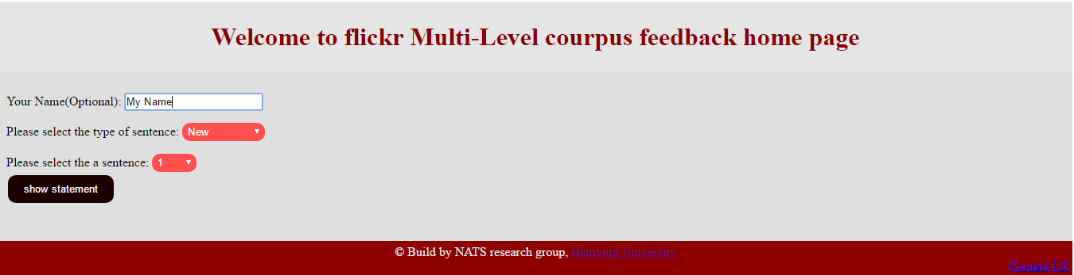

Fig. 3: SFF main page

After selecting a sentence, the user will be directed to sentence’s details page as presented in figure 4.

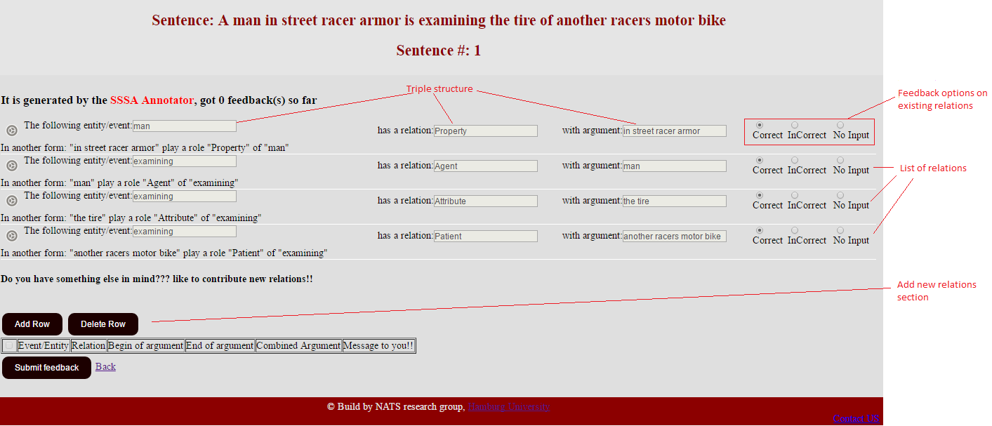

Fig. 4: SFF sentence’s details page

In sentence’s details page, the user will find the complete sentence and its number in the header section. A list of semantic relations is shown in the body. Per each relation, the user has the option to confirm, disagree with it, or give no input about it in case of uncertainty.

After checking the existing relations, the user can introduce new ones. The new relation would be a correction of existing one (similar predicate, type, and another argument) or totally a new relation. If you create a new relation to correct an error in an existing one, kindly don’t forget to label the existing one with “Incorrect” feedback.

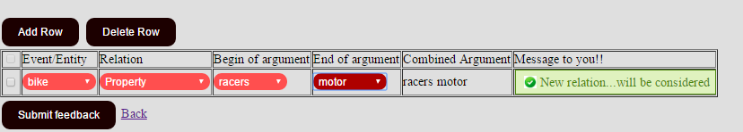

Fig. 5: adding new semantic relation section

Fig. 5 shows how the user will introduce new relation. He will select the predicate word from a list of whole sentence’s words. In addition to selecting the semantic role (relation), the user will select the argument. Due to the nature of the argument and its ability to be a phrase, the user will select the start and end words of the argument. If the argument is only one word, easily the user could select the same word as a start and end. A read-only column afterwards shows the argument phrase for the user to be sure of his selections.

The last column in such table gives a message to the user. The message might be a warning, error, or a confirmation of the apparent correctness of the new relation. Warning messages appear when the user select improper relation, for example, select a verb-predicate with a noun predicate role. But all the new relations with warning messages will be considered and saved. Few error messages appear in cases like a disorder of start and end of the argument, and other illogical inputs. New relations with an error message will not impede the form submission, but they will be bypassed from the feedback (the rest of the feedback will be ordinarily considered).

After submitting the feedback, the mission of this statement is finished, and the user could click on “check another sentence” to go back and give feedback on another sentence.

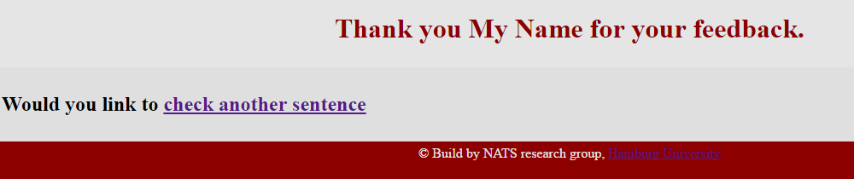

Fig. 6: Feedback submission confirmation page

After submitting the feedback (by clicking on “submit feedback button”), the newly introduced relations will be presented along with the system generated ones to any new user who likes to give feedback on this sentence afterwards. A different icon at the head of the relation records guides the user either this relation is system or user generated.



Fig. 7: SFF Different relations types

# General Feedback Notes

1. The default feedback for all the existing relations is “correct”, so the user should care about changing the feedback of the existing relations (if he wants to reject it or not to give a feedback), not only adding new relations.
2. In adding new relation, concentrating on what is the predicate and what is the argument is so critical and don’t exchange them (especially in the case of noun predicate).

With a sentence “Girl in blue dress…” the predicate is “Girl”, the relation role is “Property”, and “blue dress” is the argument. That’s because the dress is a property of the girl, not vice versa.

1. However the user is able to create different relations separately, we do recommend the user not to overlap several arguments in different relations using the same predicate. For example: “The boy jumps in the air”. We can clearly see a relation with “jumps” as a predicate, “in the air” is the argument, but is it a “Location”, or “Destination” relation? Here it depends on your personal understanding of the sentence. Theoretically, the user is able to make two different relations, one with location role, and the other with destination role. But according to what we have just mentioned, we don’t recommend to overlap arguments in different relations with same predicate. Therefore, we emphasize here to ask the user to decide first the role that “in the air” plays with “jumps” and choose only one relation to express, then express his most plausible understanding of the sentence.

On the other hand, If the sentence is “The boy jumps in the air in front of the mountain”, it is totally agreeable feedback when you create two relations with same predicate as the following:

* “jump” predicate, “Location” role, “in front of the mountain” argument.
* “jump” predicate, “Destination” role, “in the air” argument.

The agreeability here because the arguments of the two relations (with same predicate) are not overlapped.

# More Examples

For more examples of the different relations, kindly check the online help: <http://ersil.org/SFF_App/>HelpMain.php

# Contact Information

SFF is developed by NAT research group, Informatics department, Hamburg University. Contacts are appreciated and welcomed on [salama@informatik.uni-hamburg.de](mailto:salama@informatik.uni-hamburg.de)

The URL of SFF web application is <http://ersil.org/SFF_App/>

# References

|  |  |
| --- | --- |
| [1] | M. Hodosh, P. Young and J. Hockenmaier, "Framing Image Description as a Ranking Task: Data, Models and Evaluation Metrics," *Journal of Artificial Intelligence Research ,* pp. 853-899, 2013. |
| [2] | M. Hodosh, P. Young and J. Hockenmaier, "Framing image description as a ranking task:data, models and evaluation metrics," 2013. [Online]. Available: http://nlp.cs.illinois.edu/HockenmaierGroup/Framing_Image_Description/KCCA.html. |
| [3] | K. Kipper, A. Korhonen, N. Ryant and M. Palmer, "Extending VerbNet with Novel Verb Classes," in *Proceedings of the Fifth International Conference on Language Resources and Evaluation -- LREC'06*, Genoa, Italy, 2006. |

# Appendix A: Semantic Roles Shortlist

In this document, we present a shortlist of the used semantic roles.

For each semantic role, we list the different situations convenient with it. In the presented example, the **predicate** is mentioned by **Blue** font, while the **argument** is highlighted by **Red** font.

|  |  |  |  |
| --- | --- | --- | --- |
| ID | Semantic Role | Description | Relevant predicate type |
| 1.1 | Agent | The human or entity that performs the action intentionally. | Verb |
| The man kicks the ball | | | |
| 1.2 | Agent | The human or entity performs the action without active motion. It is much related to psychological verbs and body activities. | Verb |
| The man smells the fire | | | |
| 1.3 | Agent | When the initiator of the action is not a person, but a cause. | Verb |
| The cloudy weather made the game impossible | | | |
| 2.1 | Patient | The entity, affected by the action in the sentence. | Verb |
| The racer examines the motor | | |  |
| 2.2 | Patient | The affected entity in a form of relocation. | Verb |
| He drove the white bike | | |  |
| 2.3 | Patient | The final result of transformation verbs. | Verb |
| He builds the bridge out of wood | | |  |
| 2.4 | Patient | The entity described by “To Be” verb | Verb |
| The Mountain is Hugh | | |  |
| 3.1 | Attribute | Attributes of the patient. | Verb |
| The price of the oil was increased. | | |  |
| 3.2 | Attribute | The description in case of “To Be” verb | Verb |
| The Mountain is Hugh | | |  |
| 4.1 | Material | The materials are used in the transformation verbs and in stating the material of an entity. | Verb |
| He builds the bridge out of wood | | |  |
| 4.2 | Material | The material of the entity | Noun |
| The woody chair is…. | | |  |
| 5 | Beneficiary | The entity for whom the agent performs the action. | Verb |
| I made a cake for my family | | |  |
| 6 | Recipient | The target of transfer verbs. | Verb |
| I gave Julia the book | | |  |
| 7.1 | Location | The location where the verb is performed. | Verb |
| The man kicks the ball in the garden | | |  |
| 7.2 | Location | The location where the entity is located. | Noun |
| The man in the garden | | |  |
| 7.3 | Location | The location of “To Be” verb | Verb |
| The car is up on a carjack | | |  |
| 8 | Source | The source of the moving verbs. | Verb |
| He drove last night from Hamburg to Berlin | | |  |
| 9 | Destination | The destination of the moving verbs. | Verb |
| He drove last night from Hamburg to Berlin | | |  |
| 10 | Instrument | The instrument used during the action performance. | Verb |
| He wakes up usually with the morning alarm | | |  |
| 11 | Property | This role is attached to nouns (not verbs). It states a property/ownership of another object. | Noun |
| The girl with white t-shirt has just left the meeting | | |  |
| 12 | Time | The time of the action. | Verb |
| He drove last night from Hamburg to Berlin | | |  |